C H A R L E S G A N D Y K N I T S
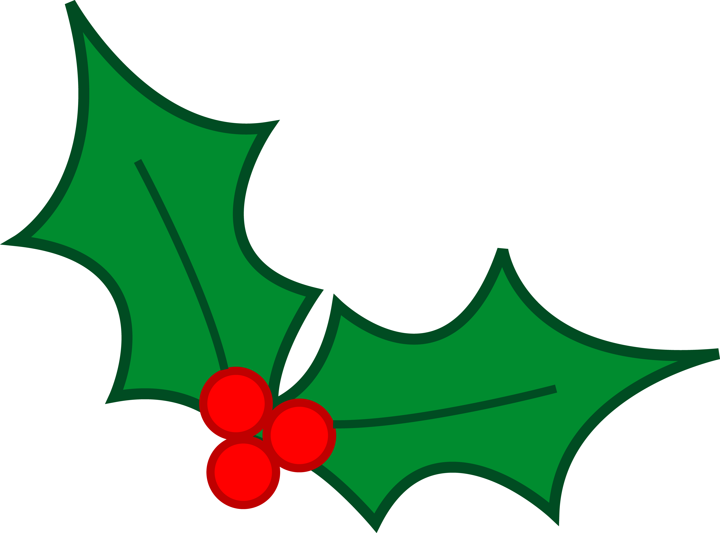

DECK THE HALLS
SUPPLIES
Please bring “Christmas colors: White, Red, & Green of an 8 ply or DK weight wool (please no acrylic!) Throw is some novelty yarns from your stash…eyelash yarns, colorful and funky (sparkly!) stuff that would make interesting embellishments on ornaments…if you are not sure bring it….bring some to share!!!

Needles that work with the above yarn, ie, somewhere between a 3.75 mm and a 5.00 mm??? We will be working in the round (don’t fret – if you have never worked in the round…we can do it another way!!!) so bring the needles that you normally work in the round with, i.e., DPNs, magic loop, or two circulars!

Of course, bring all the normal stuff: scissors, tapes, row counters, tapestry needles, a crochet hook or two, markers…things that I would think you will have in your knitting bags. I will have extras…so don’t fret!!!

HOMEWORK

All swatches are made with 8 ply or DK weight yarn on appropriate needles!
I would suggest that after you make your swatches place them in small zip lock bags and label with the number of the swatch!

- CO 20 sts and work 6 rows in STOCKING ST (Knit 1 row, Purl 1 row) Do NOT Cast off…Do NOT cut yarn.

- On DPNs CO 10 sts and work 10 rows in STOCKING ST (Knit 1 row, Purl 1 row) Do NOT Cast Off, but cut yarn leaving a 15” tail. MAKE 4 PIECES.

- On DPNs CO 10 sts and work 10 rows in GARTER ST (Knit every row) Do NOT Cast Off, but cut yarn leaving a 15” tail. MAKE 2 PIECES.

- On DPNs CO 10 sts and work 10 rows in STOCKING ST (Knit 1 row, Purl 1 row) Cast Off all stitches, leaving a 15” tail on 1 piece. MAKE 2 PIECES.

email if you have questions!!!!!
Ravelry: charlesgandyknits
charlesgandy@icloud.com

